AP Physics Free Response Practice – Momentum and Impulse

1976B2. 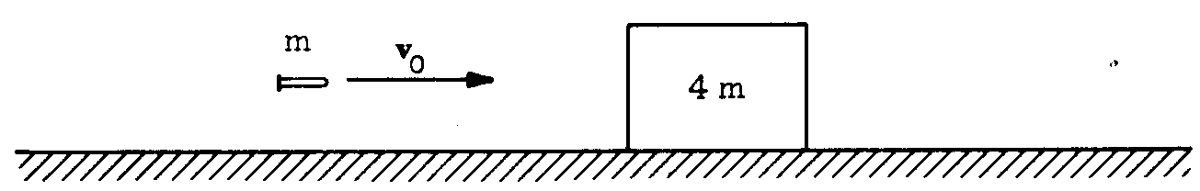
A bullet of mass m and velocity v_{o} is fired toward a block of mass 4m. The block is initially at rest on a
frictionless horizontal surface. The bullet penetrates the block and emerges with a velocity of $\frac{v_{o}}{3}$

(a) Determine the final speed of the block.
(b) Determine the loss in kinetic energy of the bullet.
(c) Determine the gain in the kinetic energy of the block.

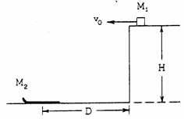

1978B2. A block of mass M₁ travels horizontally with a constant speed v_{o} on a plateau of height H until it comes to a cliff. A toboggan of mass M₂ is positioned on level ground below the cliff as shown above. The center of the toboggan is a distance D from the base of the cliff.

(a) Determine D in terms of v_{o}, H, and g so that the block lands in the center of the toboggan.
(b) The block sticks to the toboggan which is free to slide without friction. Determine the resulting velocity of the block and toboggan.


1981B2. A massless spring is between a 1-kilogram mass and a 3-kilogram mass as shown above, but is not attached to either mass. Both masses are on a horizontal frictionless table.

In an experiment, the 1-kilogram mass is held in place and the spring is compressed by pushing on the 3-kilogram mass. The 3-kilogram mass is then released and moves off with a speed of 10 meters per second.
a. Determine the minimum work needed to compress the spring in this experiment.

In a different experiment, the spring is compressed again exactly as above, but this time both masses are released simultaneously and each mass moves off separately at unknown speeds.
b. Determine the final velocity of each mass relative to the cable after the masses are released.

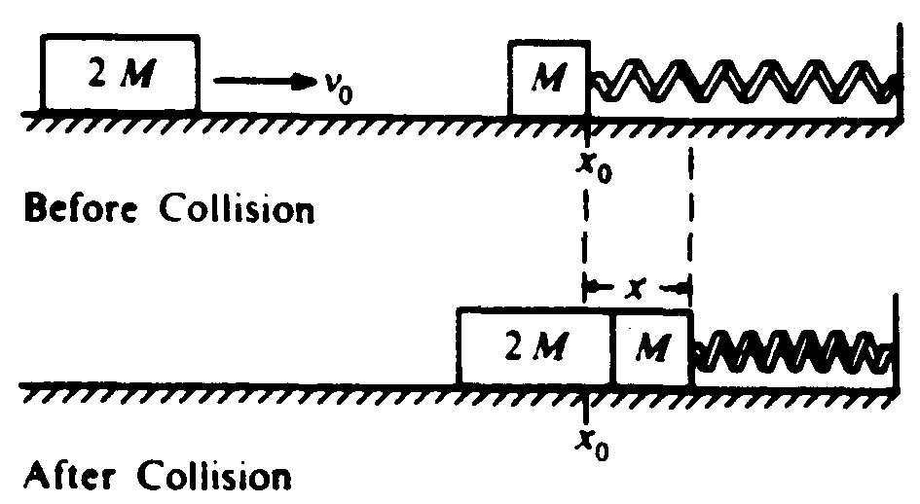

1983B2. A block of mass M is resting on a horizontal, frictionless table and is attached as shown above to a relaxed spring of spring constant k. A second block of mass 2M and initial speed v_{o} collides with and sticks to the first block. Develop expressions for the following quantities in terms of M, k, and v_{o}
a. v, the speed of the blocks immediately after impact
b. x, the maximum distance the spring is compressed

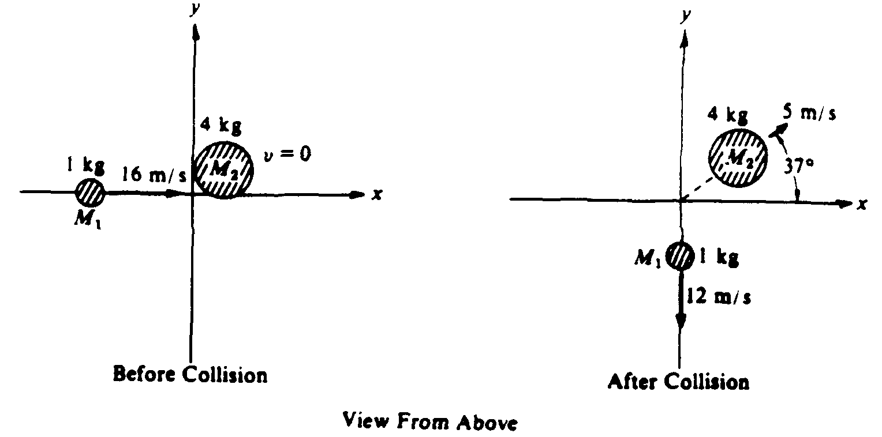
1984B2. Two objects of masses M_{l} = 1 kilogram and M₂ = 4 kilograms are free to slide on a horizontal frictionless surface. The objects collide and the magnitudes and directions of the velocities of the two objects before and after the collision are shown on the diagram above. (sin 37° = 0.6, cos 37° = 0.8, tan 37º = 0.75)
a. Calculate the x and y components (p_{x} and p_{y}, respectively) of the momenta of the two objects before and after the collision, and write your results in the proper places in the following table.
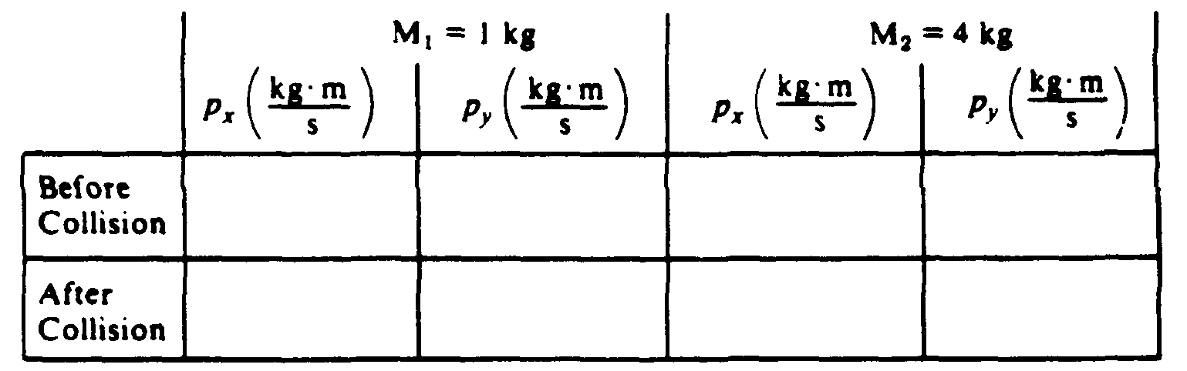
b. Show, using the data that you listed in the table, that linear momentum is conserved in this collision.
c. Calculate the kinetic energy of the two-object system before and after the collision.
d. Is kinetic energy conserved in the collision?

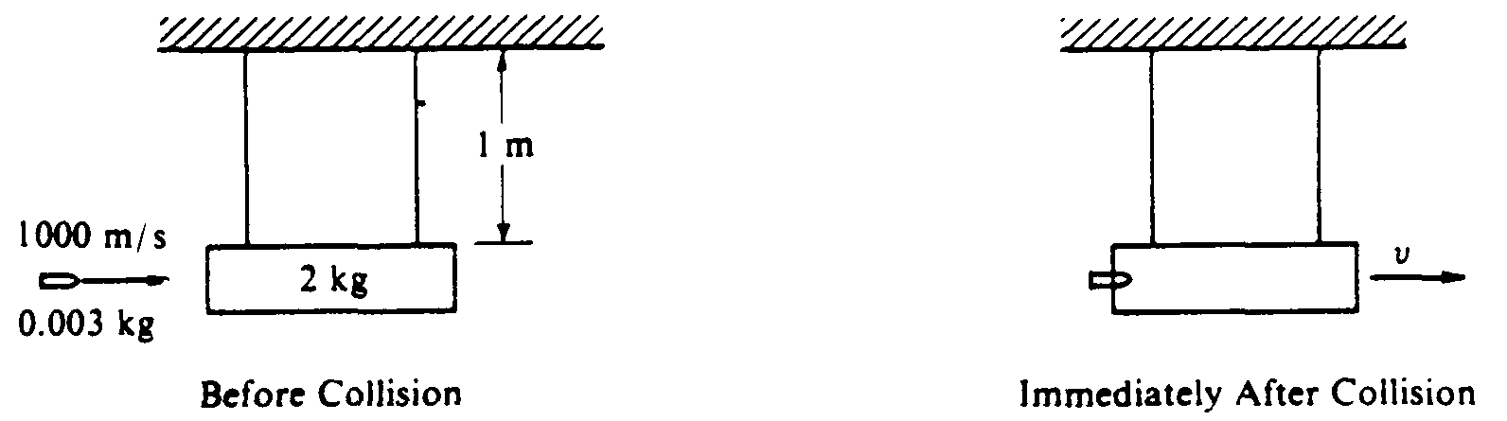

1985B1. A 2-kilogram block initially hangs at rest at the end of two 1-meter strings of negligible mass as shown on the left diagram above. A 0.003-kilogram bullet, moving horizontally with a speed of 1000 meters per second, strikes the block and becomes embedded in it. After the collision, the bullet/ block combination swings upward, but does not rotate.
a. Calculate the speed v of the bullet/ block combination just after the collision.
b. Calculate the ratio of the initial kinetic energy of the bullet to the kinetic energy of the bullet/ block combination immediately after the collision.
c. Calculate the maximum vertical height above the initial rest position reached by the bullet/block combination.

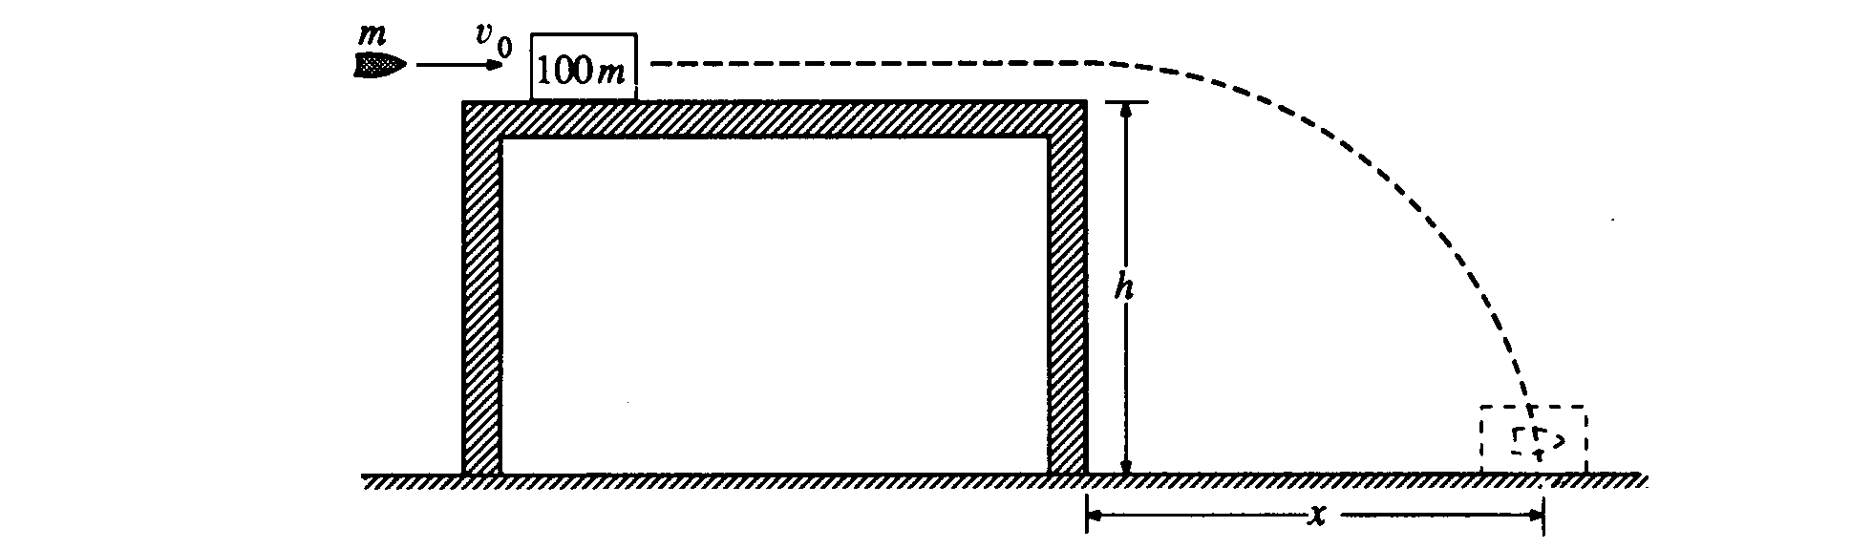
1990B1. A bullet of mass m is moving horizontally with speed v_{o} when it hits a block of mass 100m that is at rest on a horizontal frictionless table, as shown above. The surface of the table is a height h above the floor. After the impact, the bullet and the block slide off the table and hit the floor a distance x from the edge of the table. Derive expressions for the following quantities in terms of m, h, v_{o}, and appropriate constants:
a. the speed of the block as it leaves the table
b. the change in kinetic energy of the bullet-block system during impact
c. the distance x

Suppose that the bullet passes through the block instead of remaining in it.
d. State whether the time required for the block to reach the floor from the edge of the table would now be greater, less, or the same. Justify your answer.
e. State whether the distance x for the block would now be greater, less, or the same. Justify your answer.

1992B2. A 30-kilogram child moving at 4.0 meters per second jumps onto a 50-kilogram sled that is initially at rest on a long, frictionless, horizontal sheet of ice.
a. Determine the speed of the child-sled system after the child jumps onto the sled.
b. Determine the kinetic energy of the child-sled system after the child jumps onto the sled.

After coasting at constant speed for a short time, the child jumps off the sled in such a way that she is at rest with respect to the ice.
c. Determine the speed of the sled after the child jumps off it.
d. Determine the kinetic energy of the child-sled system when the child is at rest on the ice.
e. Compare the kinetic energies that were determined in parts (b) and (d). If the energy is greater in (d) than it is in (b), where did the increase come from? If the energy is less in (d) than it is in (b), where did the energy go?

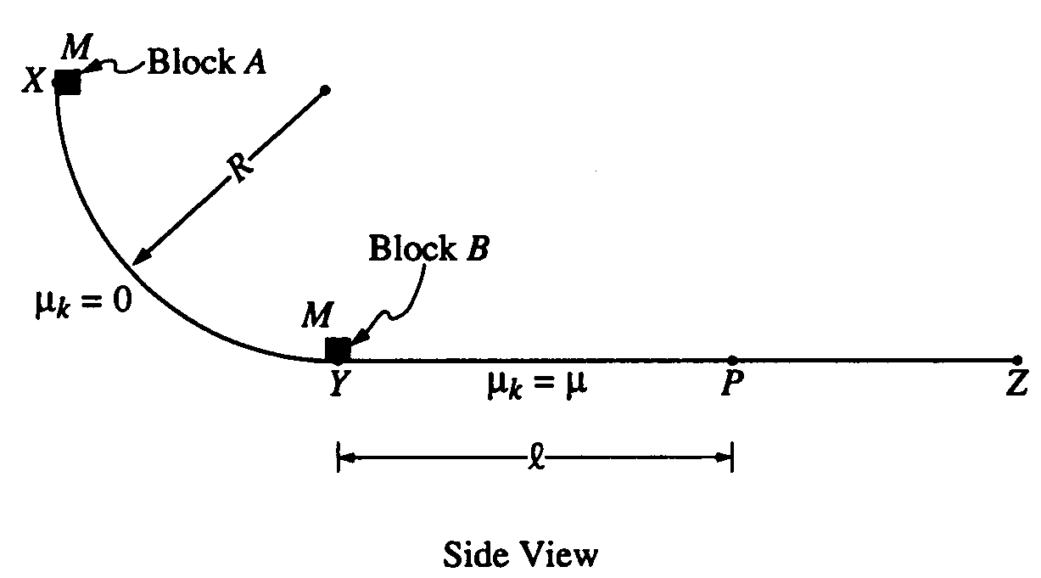

1994B2. A track consists of a frictionless arc XY, which is a quarter-circle of radius R, and a rough horizontal section YZ. Block A of mass M is released from rest at point X, slides down the curved section of the track, and collides instantaneously and inelastically with identical block B at point Y. The two blocks move together to the right, sliding past point P, which is a distance L from point Y. The coefficient of kinetic friction between the blocks and the horizontal part of the track is μ Express your answers in terms of M, L, μ, R, and g.
a. Determine the speed of block A just before it hits block B.
b. Determine the speed of the combined blocks immediately after the collision.
c. Assuming that no energy is transferred to the track or to the air surrounding the blocks. Determine the amount of internal energy transferred in the collision
d. Determine the additional thermal energy that is generated as the blocks move from Y to P

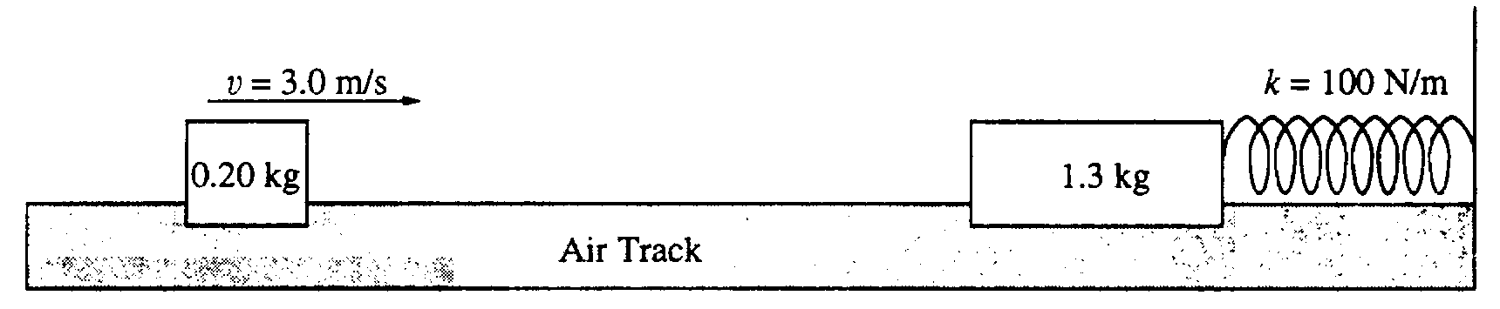

1995B1. As shown above, a 0.20-kilogram mass is sliding on a horizontal, frictionless air track with a speed of 3.0 meters per second when it instantaneously hits and sticks to a 1.3-kilogram mass initially at rest on the track. The 1.3-kilogram mass is connected to one end of a massless spring, which has a spring
constant of 100 newtons per meter. The other end of the spring is fixed.
a. Determine the following for the 0.20-kilogram mass immediately before the impact.
i. Its linear momentum ii. Its kinetic energy
b. Determine the following for the combined masses immediately after the impact.
i. The linear momentum ii. The kinetic energy

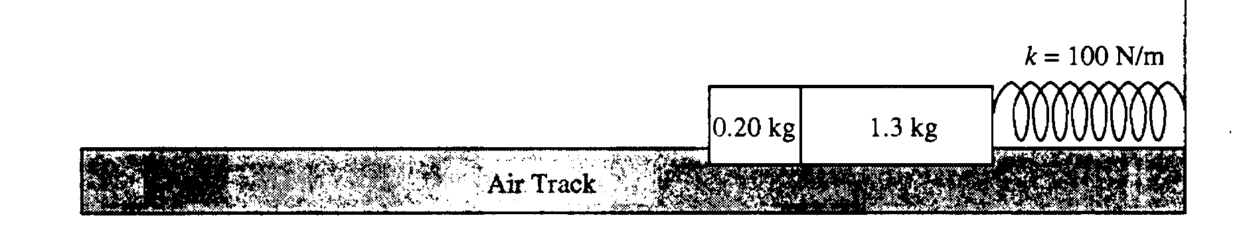
After the collision, the two masses compress the spring as shown.
c. Determine the maximum compression distance of the spring.

1996B1. Two identical objects A and B of mass M move on a one-dimensional, horizontal air track. Object B initially moves to the right with speed v_{o}. Object A initially moves to the right with speed 3v_{o}, so that it collides with object B. Friction is negligible. Express your answers to the following in terms of M and v_{o}.
a. Determine the total momentum of the system of the two objects.
b. A student predicts that the collision will be totally inelastic (the objects stick together on collision). Assuming this is true, determine the following for the two objects immediately after the collision.
i. The speed
ii. The direction of motion (left or right)

When the experiment is performed, the student is surprised to observe that the objects separate after the collision and that object B subsequently moves to the right with a speed 2.5v_{o}.
c. Determine the following for object A immediately after the collision.
i. The speed
ii. The direction of motion (left or right)
d. Determine the kinetic energy dissipated in the actual experiment.

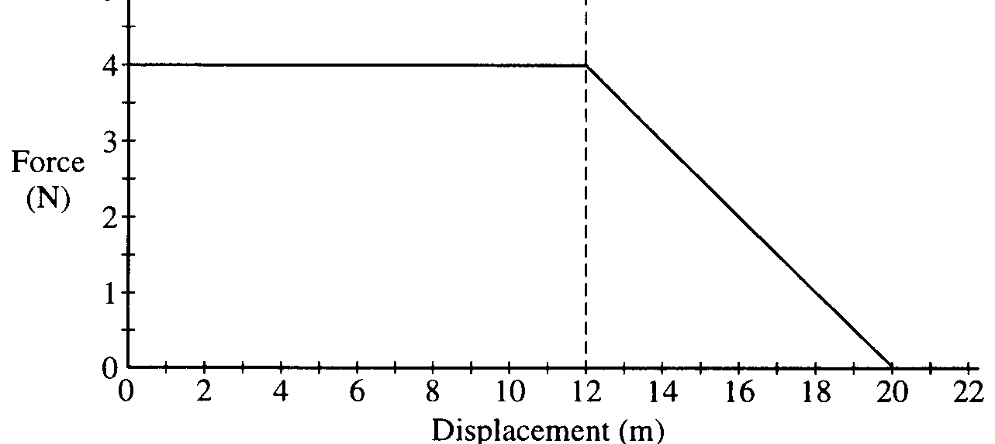

1997B1. A 0.20 kg object moves along a straight line. The net force acting on the object varies with the object's displacement as shown in the graph above. The object starts from rest at displacement x = 0 and time t = 0 and is displaced a distance of 20 m. Determine each of the following.
a. The acceleration of the particle when its displacement x is 6 m.
b. The time taken for the object to be displaced the first 12 m.
c. The amount of work done by the net force in displacing the object the first 12 m.
d. The speed of the object at displacement x = 12 m.
e. The final speed of the object at displacement x = 20 m.
f. The change in the momentum of the object as it is displaced from x = 12 m to x = 20 m

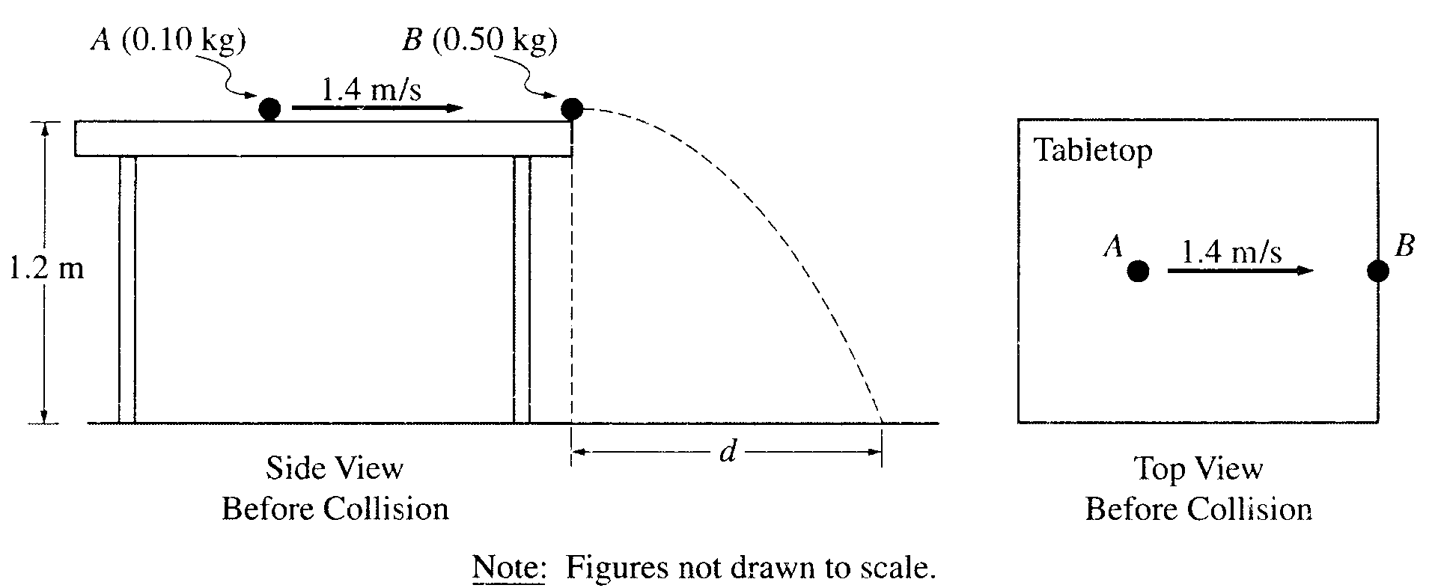

2001B2. An incident ball A of mass 0.10 kg is sliding at 1.4 m/s on the horizontal tabletop of negligible friction as shown above. It makes a head-on collision with a target ball B of mass 0.50 kg at rest at the edge of the table. As a result of the collision, the incident ball rebounds, sliding backwards at 0.70 m/s immediately after the collision.
a. Calculate the speed of the 0.50 kg target ball immediately after the collision.

The tabletop is 1.20 m above a level, horizontal floor. The target ball is projected horizontally and initially strikes the floor at a horizontal displacement d from the point of collision.
b. Calculate the horizontal displacement

In another experiment on the same table, the target ball B is replaced by target ball C of mass 0.10 kg. The incident ball A again slides at 1.4 m/s, as shown below left, but this time makes a glancing collision with the target ball C that is at rest at the edge of the table. The target ball C strikes the floor at point P, which is at a horizontal displacement of 0.15 m from the point of the collision, and at a horizontal angle of 30° from the +x-axis, as shown below right. 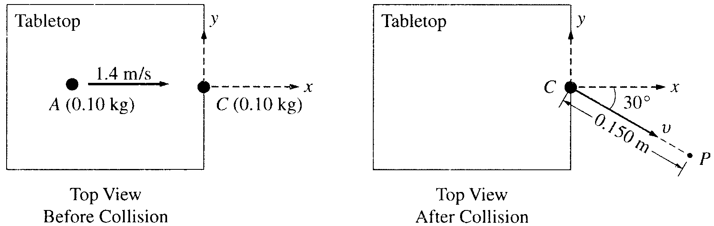

c. Calculate the speed v of the target ball C immediately after the collision.
d. Calculate the y-component of incident ball A's momentum immediately after the collision.
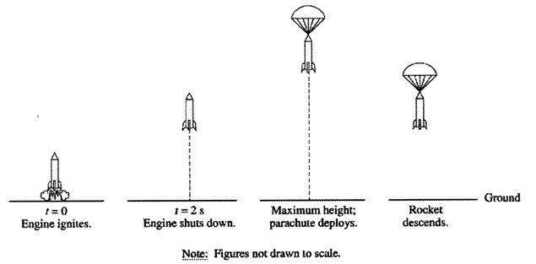
2002B1. A model rocket of mass 0.250 kg is launched vertically with an engine that is ignited at time t = 0, as shown above. The engine provides an impulse of 20.0 N•s by firing for 2.0 s. Upon reaching its maximum height, the rocket deploys a parachute, and then descends vertically to the ground.

(a) On the figures below, draw and label a free-body diagram for the rocket during each of the following intervals.

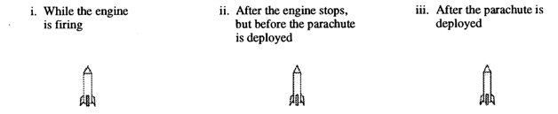

(b) Determine the magnitude of the average acceleration of the rocket during the 2 s firing of the engine.

(c) What maximum height will the rocket reach?

(d) At what time after t = 0 will the maximum height be reached?
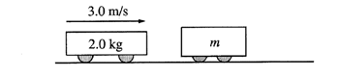
2002B1B. A 2.0 kg frictionless cart is moving at a constant speed of 3.0 m/s to the right on a horizontal surface, as shown above, when it collides with a second cart of undetermined mass m that is initially at rest. The force F of the collision as a function of time t is shown in the graph below, where t = 0 is the instant of initial contact. As a result of the collision, the second cart acquires a speed of 1.6 m/s to the right. Assume that friction is negligible before, during, and after the collision.
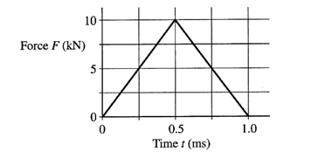
(a) Calculate the magnitude and direction of the velocity of the 2.0 kg cart after the collision.

(b) Calculate the mass m of the second cart.

After the collision, the second cart eventually experiences a ramp, which it traverses with no frictional losses. The graph below shows the speed v of the second cart as a function of time t for the next 5.0 s, where t = 0 is now the instant at which the carts separate.
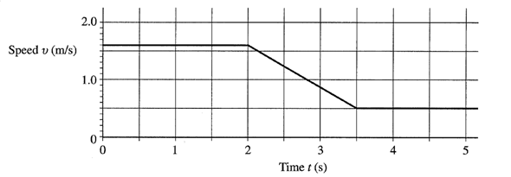
(c) Calculate the acceleration of the cart at t = 3.0 s.

(d) Calculate the distance traveled by the second cart during the 5.0 s interval after the collision (0 s < t < 5.0 s).

(e) State whether the ramp goes up or down and calculate the maximum elevation (above or below the initial height) reached by the second cart on the ramp during the 5.0 s interval after the collision (0 s < t < 5.0 s).
2006B2B

A small block of mass M is released from rest at the top of the curved frictionless ramp shown above. The block slides down the ramp and is moving with a speed 3.5v_{o} when it collides with a larger block of mass 1.5M at rest at the bottom of the incline. The larger block moves to the right at a speed 2 v_{o} immediately after the collision. Express your answers to the following questions in terms of the given quantities and fundamental constants.

(a) Determine the height h of the ramp from which the small block was released.
(b) Determine the speed of the small block after the collision.
(c) The larger block slides a distance D before coming to rest. Determine the value of the coefficient of kinetic friction µ between the larger block and the surface on which it slides.
(d) Indicate whether the collision between the two blocks is elastic or inelastic. Justify your answer.

2008B1B
A 70 kg woman and her 35 kg son are standing at rest on an ice rink, as shown above. They push against each other for a time of 0.60 s, causing them to glide apart. The speed of the woman immediately after they separate is 0.55 m/s. Assume that during the push, friction is negligible compared with the forces the people exert on each other.

(a) Calculate the initial speed of the son after the push.
(b) Calculate the magnitude of the average force exerted on the son by the mother during the push.
(c) How do the magnitude and direction of the average force exerted on the mother by the son during the push compare with those of the average force exerted on the son by the mother? Justify your answer.
(d) After the initial push, the friction that the ice exerts cannot be considered negligible, and the mother comes to rest after moving a distance of 7.0 m across the ice. If their coefficients of friction are the same, how far does the son move after the push?
2008B1

Several students are riding in bumper cars at an amusement park. The combined mass of car A and its occupants is 250 kg. The combined mass of car B and its occupants is 200 kg. Car A is 15 m away from car B and moving to the right at 2.0 m/s, as shown, when the driver decides to bump into car B, which is at rest.

(a) Car A accelerates at 1.5 m/s² to a speed of 5.0 m/s and then continues at constant velocity until it strikes car B. Calculate the total time for car A to travel the 15 m.
(b) After the collision, car B moves to the right at a speed of 4.8 m/s .
i. Calculate the speed of car A after the collision.
ii. Indicate the direction of motion of car A after the collision.
____ To the left ____ To the right ____ None; car A is at rest.
(c) Is this an elastic collision?
____ Yes ____ No
Justify your answer.

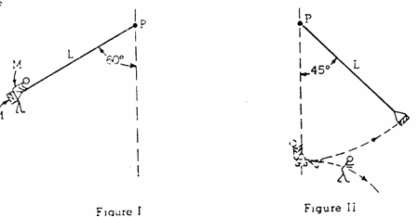

C1981M2. A swing seat of mass M is connected to a fixed point P by a massless cord of length L. A child also of mass M sits on the seat and begins to swing with zero velocity at a position at which the cord makes a 60° angle with the vertical is shown in Figure I. The swing continues down until the cord is exactly vertical at which time the child jumps off in a horizontal direction. The swing continues in the same direction until its cord makes a 45° angle with the vertical as shown in Figure II: at that point it begins to swing in the reverse direction.
a) Determine the speed of the child and seat just at the lowest position prior to the child’s dismount from the seat
b) Determine the speed if the seat immediately after the child dismounts
c) Determine the speed of the child immediately after he dismounts from the swing?

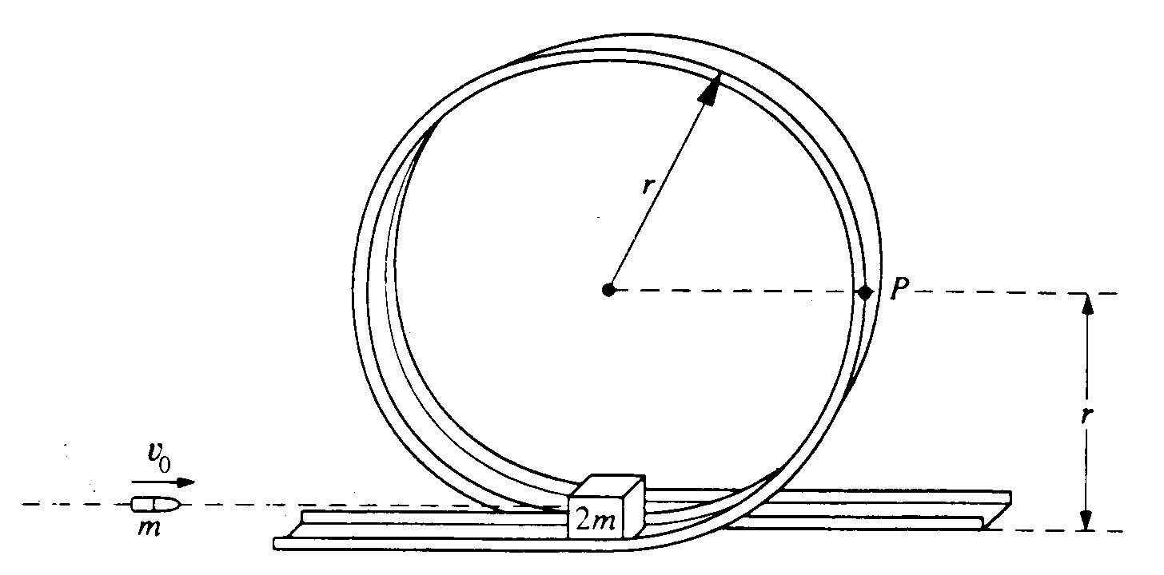

C1991M1. A small block of mass 2m initially rests on a track at the bottom of the circular, vertical loop-the-loop shown above, which has a radius r. The surface contact between the block and the loop is frictionless. A bullet of mass m strikes the block horizontally with initial speed v_{o} and remains embedded in the block as the block and bullet circle the loop.
Determine each of the following in terms of m, v_{o}, r, and g.
a. The speed of the block and bullet immediately after impact
b. The kinetic energy of the block and bullet when they reach point P on the loop
c. The speed v_{min} of the block at the top of the loop to remain in contact with track at all times
d The new required entry speed v_{o}’ of the block and bullet at the bottom of the loop such that the conditions in part c apply.
e. The new initial speed of the bullet to produce the speed from part d above.
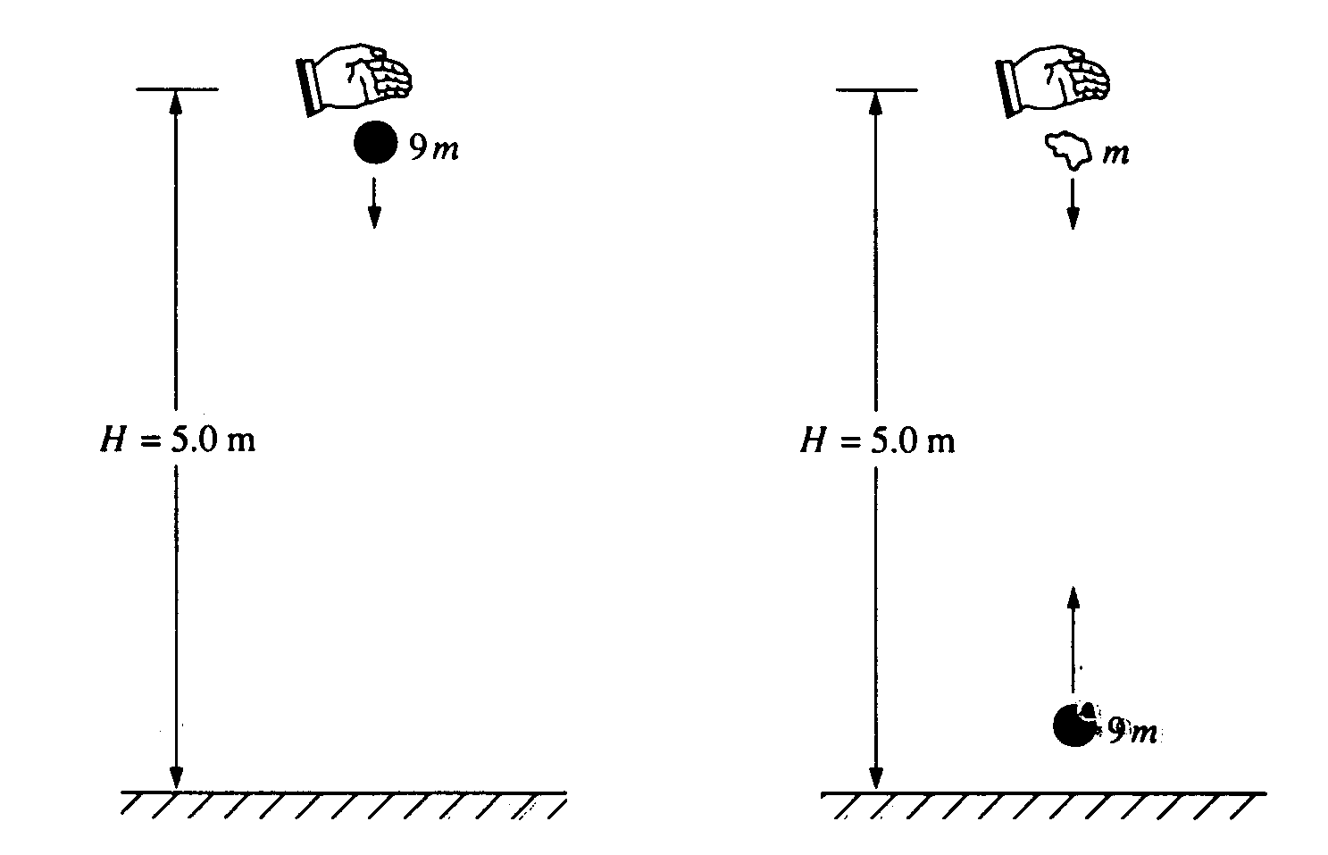
C1992M1. A ball of mass 9m is dropped from rest from a height H = 5.0 meters above the ground, as shown above on the left. It undergoes a perfectly elastic collision with the ground and rebounds. At the instant that the ball rebounds, a small blob of clay of mass m is released from rest from the original height H, directly above the ball, as shown above on the right. The clay blob, which is descending, collides with the ball 0.5 seconds later, which is ascending. Assume that g = 10 m/s², that air resistance is negligible, and that the collision process takes negligible time.
a. Determine the speed of the ball immediately before it hits the ground.
b. Determine the rebound speed of the ball immediately after it collides with the ground, justify your answer.
c. Determine the height above the ground at which the clay-ball collision takes place.
d. Determine the speeds of the ball and the clay blob immediately before the collision.
e. If the ball and the clay blob stick together on impact, what is the magnitude and direction of their velocity immediately after the collision?

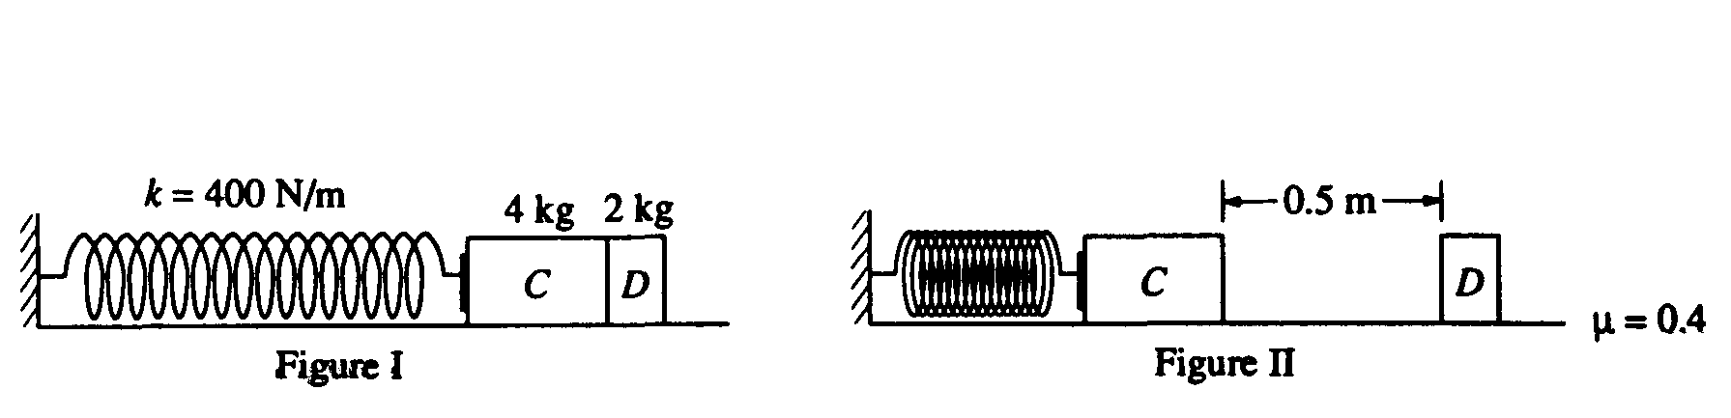
C1993M1. A massless spring with force constant k = 400 newtons per meter is fastened at its left end to a vertical wall, as shown in Figure 1. Initially, block C (mass m_{c} = 4.0 kilograms) and block D (mass m_{D} = 2.0 kilograms) rest on a horizontal surface with block C in contact with the spring (but not compressing it) and with block D in contact with block C. Block C is then moved to the left, compressing the spring a distance of 0.50 meter, and held in place while block D remains at rest as shown in Figure 11. (Use g = 10 m/s².)
a. Determine the elastic energy stored in the compressed spring.

Block C is then released and accelerates to the right, toward block D. The surface is rough and the coefficient of friction between each block and the surface is μ = 0.4. The two blocks collide instantaneously, stick together, and move to the right. Remember that the spring is not attached to block C. Determine each of the following.
b. The speed v_{c} of block C just before it collides with block D
c. The speed v_{f} of blocks C and D just after they collide
d. The horizontal distance the blocks move before coming to rest

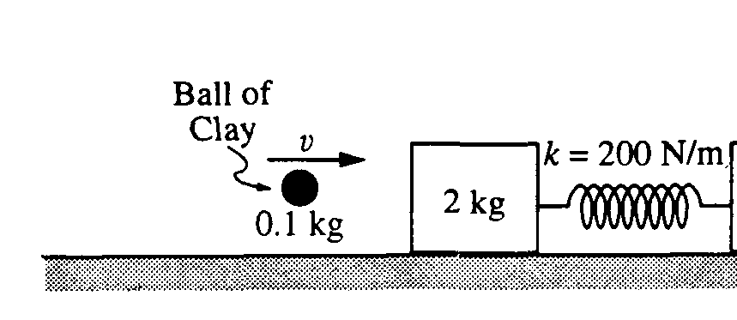

C1994M1. A 2-kilogram block is attached to an ideal spring (for which k = 200 N/m) and initially at rest on a horizontal frictionless surface, as shown in the diagram above.

In an initial experiment, a 100-gram (0.1 kg) ball of clay is thrown at the 2-kilogram block. The clay is moving horizontally with speed v when it hits and sticks to the block. The spring is attached to a wall as shown. As a result, the spring compresses a maximum distance of 0.4 meters.
a. Calculate the energy stored in the spring at maximum compression.
b. Calculate the speed of the clay ball and 2-kilogram block immediately after the clay sticks to the block but before the spring compresses significantly.
c. Calculate the initial speed v of the clay.

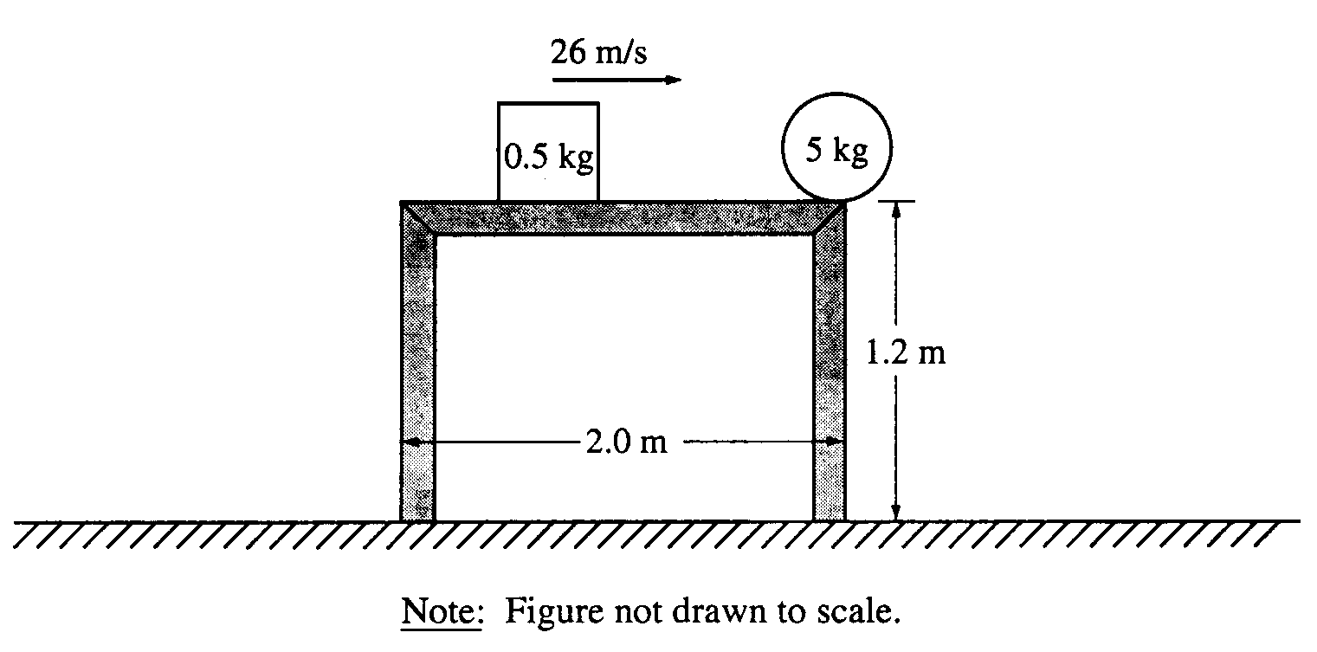

C1995M1. A 5-kilogram ball initially rests at the edge of a 2-meter-long, 1.2-meter-high frictionless table, as shown above. A hard plastic cube of mass 0.5 kilogram slides across the table at a speed of 26 meters per second and strikes the ball, causing the ball to leave the table in the direction in which the cube was moving. The figure below shows a graph of the force exerted on the ball by the cube as a function of time.

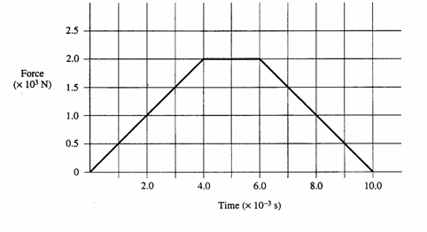
a. Determine the total impulse given to the ball.
b. Determine the horizontal velocity of the ball immediately after the collision.
c. Determine the following for the cube immediately after the collision.
i. Its speed
ii. Its direction of travel (right or left), if moving
d. Determine the kinetic energy dissipated in the collision.
e. Determine the distance between the two points of impact of the objects with the floor.
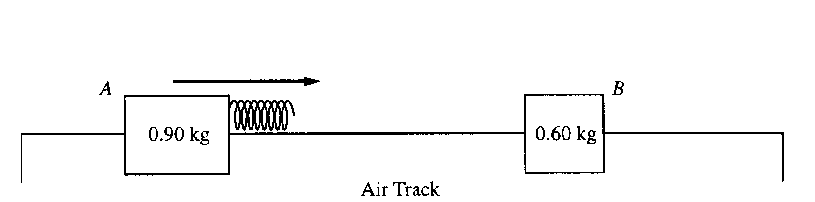

C1998M1. Two gliders move freely on an air track with negligible friction, as shown above. Glider A has a mass of 0.90 kg and glider B has a mass of 0.60 kg. Initially, glider A moves toward glider B, which is at rest. A spring of negligible mass is attached to the right side of glider A. Strobe photography is used to record successive positions of glider A at 0.10 s intervals over a total time of 2.00 s, during which time it collides with glider B.

The following diagram represents the data for the motion of glider A. Positions of glider A at the end of each 0.10s interval are indicated by the symbol ʌ against a metric ruler. The total elapsed time t after each 0.50 s is also indicated.
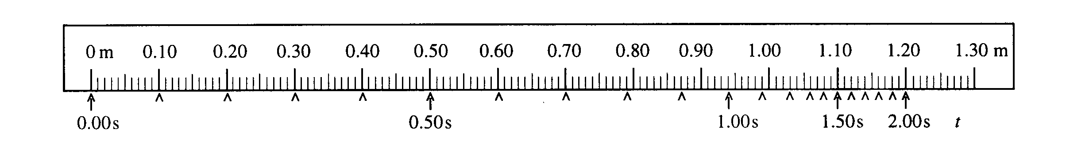

a. Determine the average speed of glider A for the following time intervals.

i. 0.0 s to 0.30 s ii. 0.90 s to 1.10 s iii. 1.70 s to 1.90 s

b. On the axes below, sketch a graph, consistent with the data above, of the speed of glider A as a function of
time t for the 2.00 s interval.
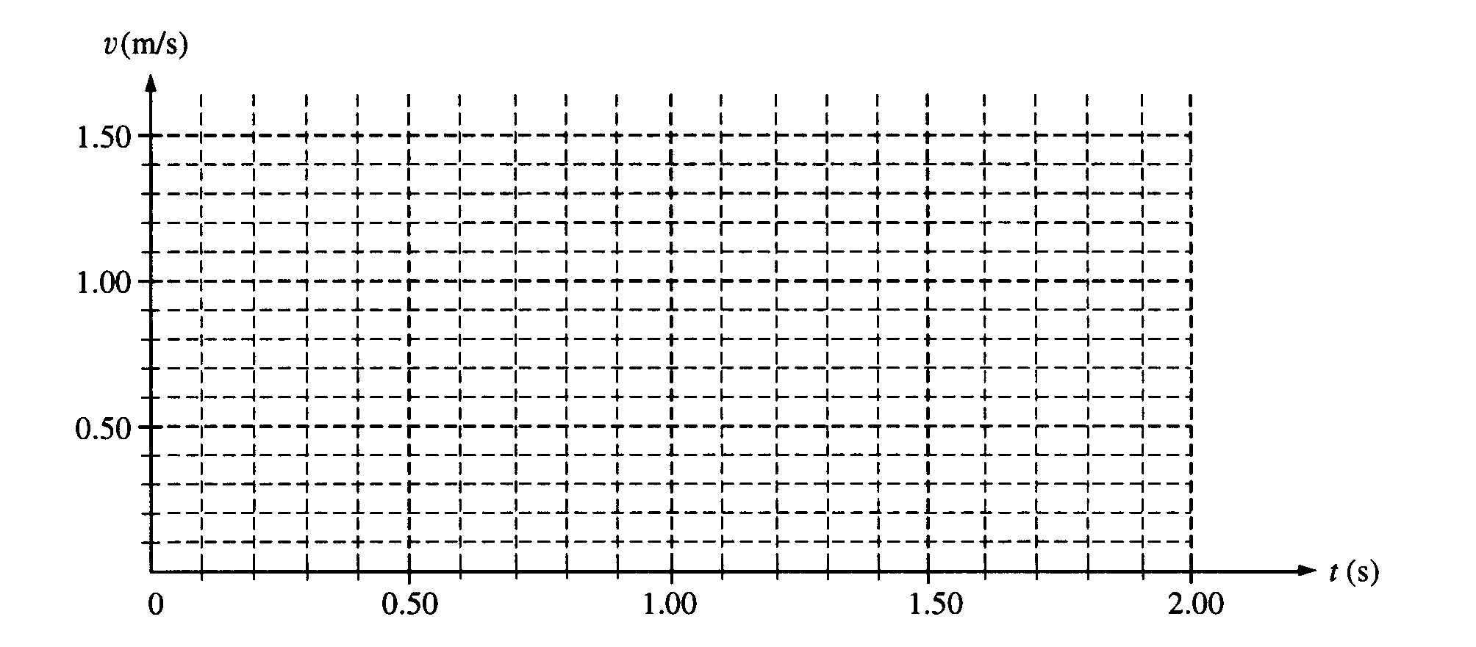

c. i. Use the data to calculate the speed of glider B immediately after it separates from the spring.
ii. On the axes below, sketch a graph of the speed of glider B as a function of time t.

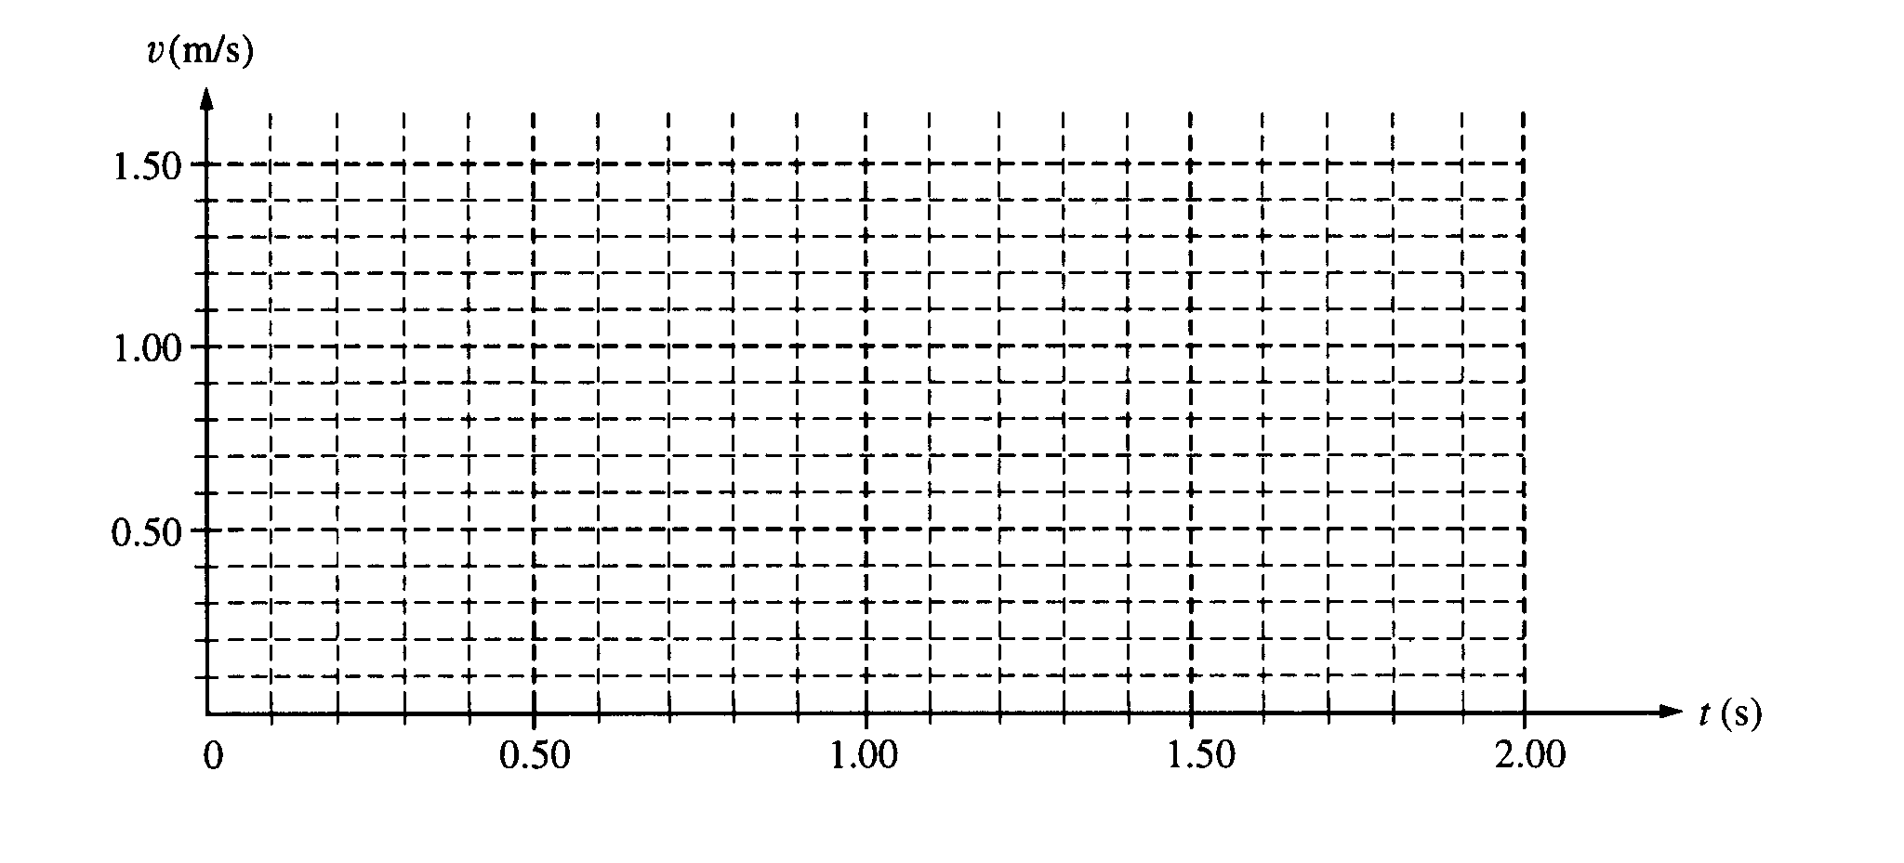
A graph of the total kinetic energy K for the two-glider system over the 2.00 s interval has the following shape.
K_{o} is the total kinetic energy of the system at time t = 0.
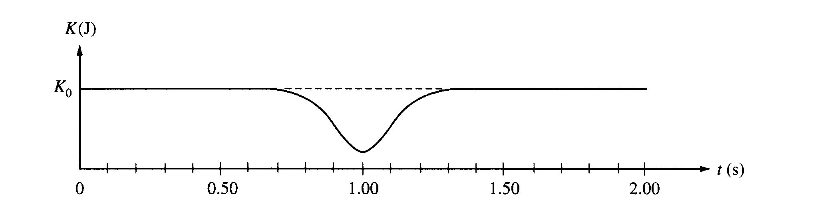

d. i. Is the collision elastic? Justify your answer.

ii. Briefly explain why there is a minimum in the kinetic energy curve at t = 1.00 s.

C1999M1. In a laboratory experiment, you wish to determine the initial speed of a dart just after it leaves a dart gun. The dart, of mass m, is fired with the gun very close to a wooden block of mass M_{o} which hangs from a cord of length l and negligible mass, as shown. Assume the size of the block is negligible compared to l, and the dart is moving horizontally when it hits the left side of the block at its center and becomes embedded in it. The block swings up to a maximum angle from the vertical. Express your answers to the following in terms of
m, M₀, l, θ_{max}, and g.
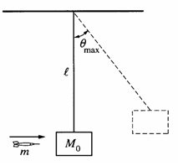
a. Determine the speed v_{o} of the dart immediately before it strikes the block.
b. The dart and block subsequently swing as a pendulum. Determine the tension in the cord when it returns to the lowest point of the swing.
c. At your lab table you have only the following additional equipment.

Meter stick Stopwatch Set of known masses Protractor
5 m of string Five more blocks of mass M₀ Spring
Without destroying or disassembling any of this equipment, design another practical method for determining the speed of the dart just after it leaves the gun. Indicate the measurements you would take, and how the speed could be determined from these measurements.

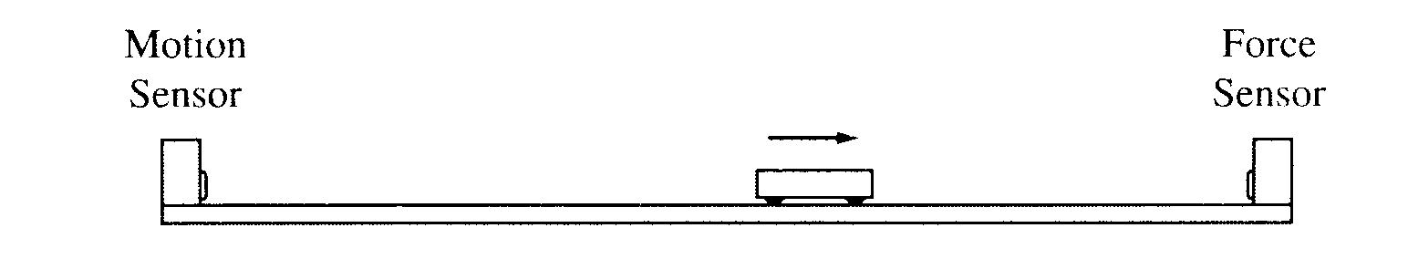

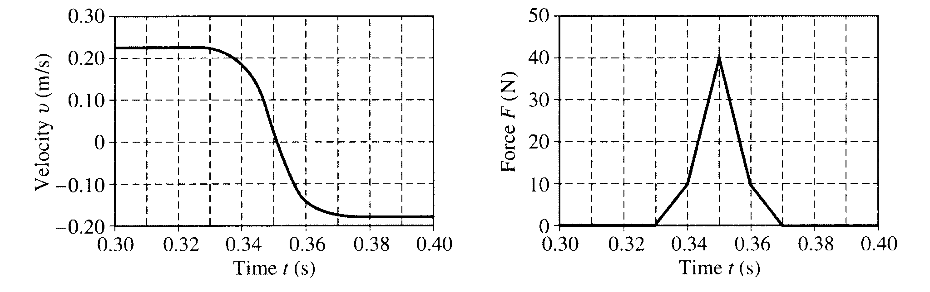

2001M1. A motion sensor and a force sensor record the motion of a cart along a track, as shown above. The cart is given a push so that it moves toward the force sensor and then collides with it. The two sensors record the values shown in the following graphs.
a. Determine the cart's average acceleration between t = 0.33 s and t = 0.37 s.
b. Determine the magnitude of the change in the cart's momentum during the collision.
c. Determine the mass of the cart.
d. Determine the energy lost in the collision between the force sensor and the cart

C2003M2.
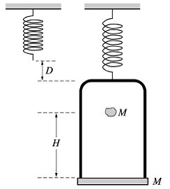
An ideal massless spring is hung from the ceiling and a pan suspension of total mass M is suspended from the end of the spring. A piece of clay, also of mass M, is then dropped from a height H onto the pan and sticks to it. Express all algebraic answers in terms of the given quantities and fundamental constants.

(a) Determine the speed of the clay at the instant it hits the pan.
(b) Determine the speed of the pan just after the clay strikes it.
(c) After the collision, the apparatus comes to rest at a distance H/2 below the current position. Determine the spring constant of the attached spring.

C2004M1.

A rope of length L is attached to a support at point C. A person of mass m₁ sits on a ledge at position A holding
the other end of the rope so that it is horizontal and taut, as shown. The person then drops off the ledge
and swings down on the rope toward position B on a lower ledge where an object of mass m₂ is at rest. At
position B the person grabs hold of the object and simultaneously lets go of the rope. The person and object then land together in the lake at point D, which is a vertical distance L below position B. Air resistance and the mass of the rope are negligible. Derive expressions for each of the following in terms of
m₁, m₂, L, and g.

(a) The speed of the person just before the collision with the object
(b) The tension in the rope just before the collision with the object
(c) The speed of the person and object just after the collision
(d) The total horizontal displacement x of the person from position A until the person and object land in the
water at point D.

