LAKE SHORE CENTRAL SCHOOLS
MIDDLE SCHOOL

Erich Reidell, Principal

8855 Erie Road, Angola, NY 14006 Phone: (716) 926-2400 Fax: (716) 549-4374

E-mail: ereidell@lakeshorecsd.org

September 2014

Dear Parents/Guardians:

On Thursday evening, September 18, 2014, the annual Middle School Open House will be held. The program begins at 7:00 p.m. and will provide parents with an opportunity to follow their child’s daily schedule. Although the class periods are brief, parents will be able to meet the teachers and hear a presentation regarding each of the subject areas.

Your son or daughter’s schedule is provided on the back of this letter. Please feel free to visit the Media Center or Health Office as well. It is recommended that students do not attend the Open House, as seating is limited in many of the rooms.

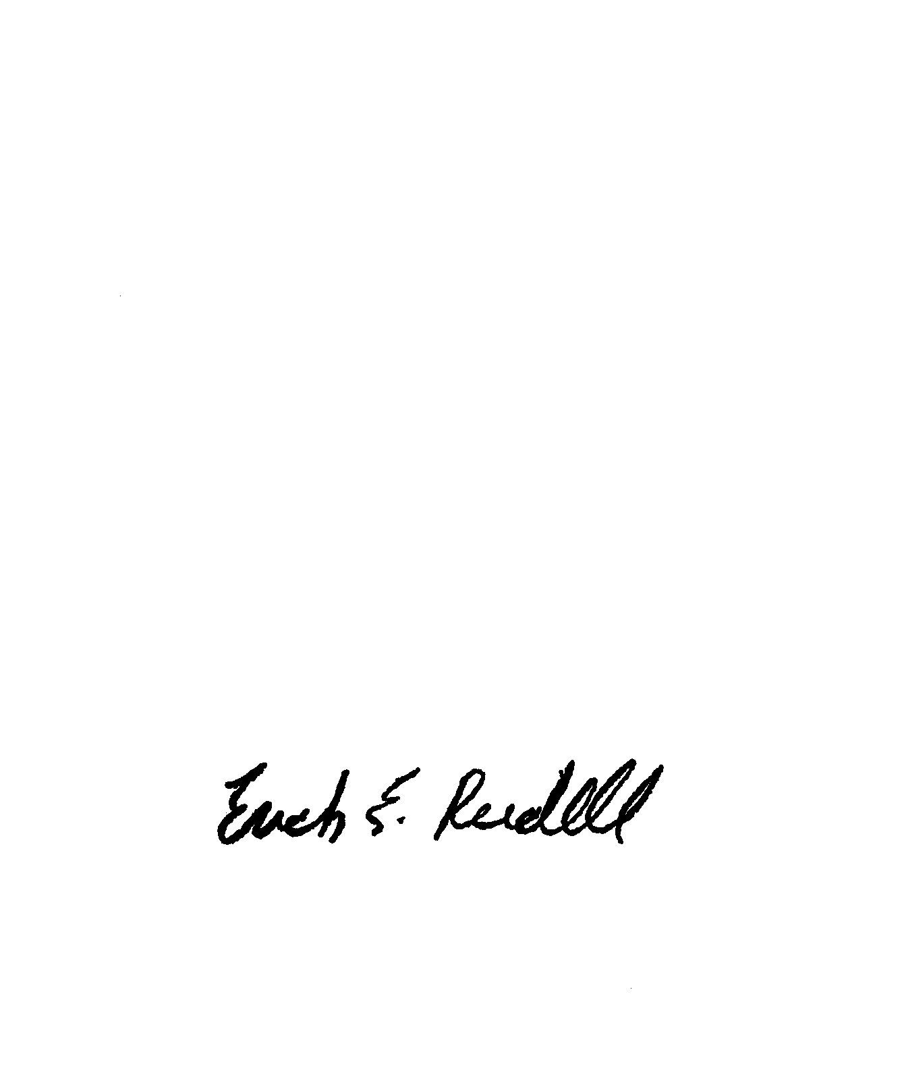
We look forward to meeting you at Open House. If you are unable to attend this program, please feel free to stop at the school at any time. Your continuing interest in your child’s education is appreciated.

Sincerely,

Erich Reidell

Middle School Principal

ER:jc

